1. Check for component assembled as per BOM issued.
2. Check that laser mark is correctly printed or not.
3. Check that both cable 5-core and 3-core is 5 Meter length.
4. Check at connector J2 AC supply cable Live and Neutral.
5. Check connector J4 free cable is for relay.
6. Check cable coming from gland is correct or not.
7. Check sticker is assembled properly.
8. Check final assembly of Anti-collision system is as shown in below image.

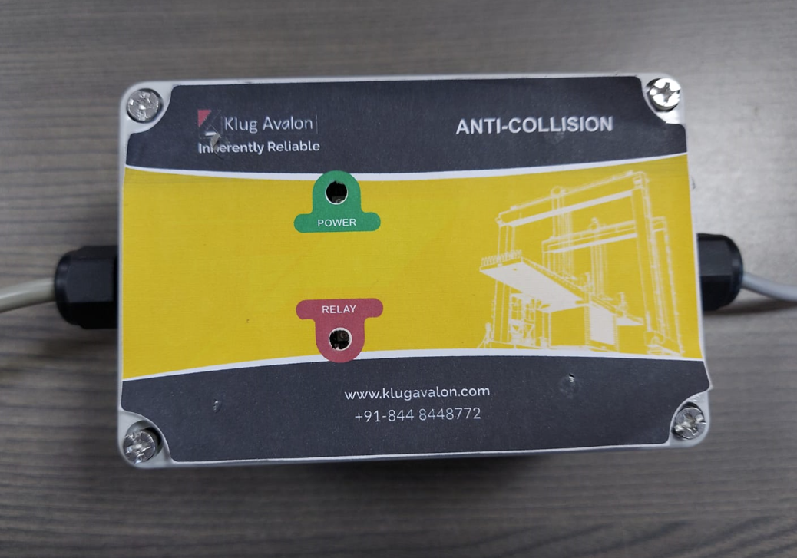

1. Refer silkscreen for connection of connectors J2, J3 AND J4.

